**PROPOSED TITLE: -**

Expense Tracker Website

**Field of invention**: -

Improving accuracy and representation by applying various machine learning algorithms on a dataset of income.

**Background:**

Monetary management is still an important issue for a long period. People use chequebooks or spreadsheets to track their spending. But sometimes, they lost their chequebooks and even their spreadsheets which they keep to store their whole monthly spending. This old method was very hectic. At the month's end, the user had to find out all their records and then calculate to find their whole monthly spending. But this method is not efficient to track all the records.

As the technology comes, an application was developed by the developers which are Notes. The user can note down all the expenses. But consider a situation where the user accidentally uninstalls the application. So in that case all the data also be lost. This issue is recognized by many companies like Google.

So Google synchronized all the user’s data to keep it safe in many ways like notes down, pictures or even some reminders for an event. But we can’t say that Google Notes can manage their expenses. They can’t calculate whole expenses or even give require suggestions.

So, we developed a web-based application that is Expense Tracker. It helps the user to keep up with the spending. The users need to give some useful information about their spending and monthly budget, so according to their data, the user can get a pictorial representation of their spending.

**Objectives:**

* Prepare a model which can recommend more useful ways to spend the money.
* To help segregate the expense and show it in a graphical way which makes it more comfortable to understand.
* To develop a habit of recording each expense which makes it more spending more traceable.
* Provide remainder based on early spending.

**Flow chart/Model:**

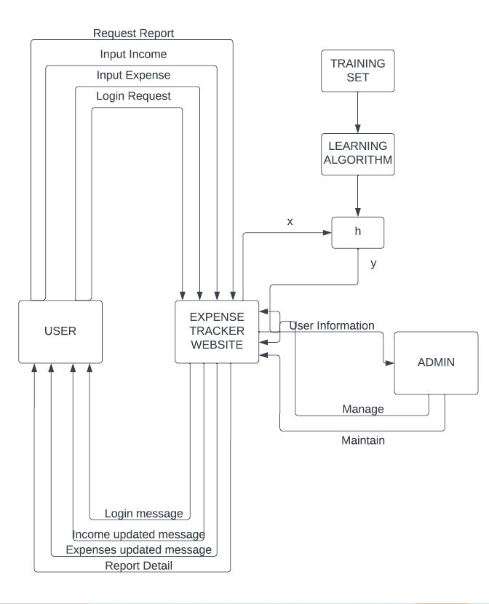

**Claims:**

Our model will provide a platform to note up the expenses and use them to limit or use them in more important and useful ways. It will provide a speech recognition feature that will help to add the expenses by verbally it. Machine learning is used to recommend using money on different items. It will provide the remainder based on previous expense history. All these features made it a complete package that will help the user to cater for its various demands.

**Technology used:**

Software:

* Python for Machine Learning
* Jupyter notebook
* Mongo DB
* Html
* Tailwind CSS
* React Js
* Express Js
* Node Js
* Windows 7 and above

Hardware:

* Processor: Above intel i3 or AMD Ryzen 3
* RAM: 4/8 GB

**Abstract:**

Expense Tracker is a web Based Application that allows the user to maintain a digital diary. This application will keep track of all expense records of the user and give the user a category-wise distribution of their expenses. An expense history will also be provided to the user by application. The user can view their expense record in the pictorial representation. They also can filter the records by date or daily, weekly, or monthly. The system design is dynamic so it used the linear regressions method to produce the prediction. The system takes some users' information to analyse their whole expenditure. This app will be an approach for people to manage their expenditures in efficient ways.

**End users:**

Any person who wants to manage their expense.

**Advantage:**

* This system helps to reduce the time spent on separately writing and then calculating expenses in a notebook.
* This system will supply an interface to segregate and consolidate expense data according to the need of the user.
* It will provide a Graphical representation of different items where money is spent which will make it easy to understand and use.

**Conclusion:**

Expense tracking is an important aspect of personal finance management, and innovative technologies and ideas offer exciting opportunities to make this task faster, more accurate, and more automated. The project aimed to make an application that helps users to handle personal finances by automating the typical steps. This application helps all those people who want to track their expenses. It will give a better sense of the expenditure by promoting savings. Machine learning is a required skill nowadays. This project also used some basic machine-learning techniques.